IBM SPSS Modeler Project

Project Title:
Predictive Modeling of Diabetes Using CHAID Decision Trees in SPSS Modeler Using IBM SPSS Modeler

Submitted by: Somen Mandal
Rahul Kar Modak
Harsh Kr Singh
Course: B.Tech CSE (AI & DS)
Semester: 5th
Institution: Arka Jain University
Guide: Mr. Prajwal Deep Khokhar
Date: 22-11-2025

Index
S. No. | Contents | Page No.
1. | Project Brief | 3
2. | Introduction | 4
3. | Feasibility Study | 5
4. | Project Details | 6
 | 4.1 Datasets Used | 6
 | 4.2 Data Understanding and Preparation | 6-7
 | 4.3 Model Building (CHAID Model 1 – Diabetes Prediction) | 7-9
 | 4.4 Model Building (CHAID Model 2 – BMI Category Prediction) | 9-12
 | 4.5 Model Building (CHAID Model 3 – Glucose Level Category Prediction) | 12
 | 4.6 Model Building (CHAID Model 4 – Age Group Prediction) | 13-14
5. | Model Evaluation and Comparison | 15
6. | Conclusion / Summary | 16

1. Project Brief
1. Project Brief
This project focuses on applying predictive analytics and decision-tree–based modeling using IBM SPSS Modeler to analyze and classify diabetes outcomes using the PIMA Indians Diabetes Dataset.
The project explores five key CHAID-based applications —
- Diabetes Outcome Prediction,
- BMI Category Analysis,
- Glucose Level Categorization,
- Age Group Classification
The main objective is to identify the most influential medical and physiological factors that contribute to diabetes and to build interpretable CHAID decision-tree models for accurate medical classification and early-risk detection.
The project demonstrates how predictive modeling (supervised learning) and descriptive analytics can be applied to healthcare datasets to extract medically valuable insights for early diagnosis, patient profiling, and better clinical decision-making.

2. Introduction
Healthcare analytics is one of the most important applications of data science because early detection of diseases can significantly improve treatment outcomes. Diabetes, in particular, is a widespread chronic disease caused by high blood sugar levels.
Machine learning techniques allow us to analyze medical features such as glucose, BMI, blood pressure, age, and insulin to understand patterns and detect diabetes at an early stage.
In this project, we use the CHAID (Chi-square Automatic Interaction Detection) algorithm, a decision-tree method available in IBM SPSS Modeler. CHAID is especially useful in healthcare because:
- It provides simple decision rules
- It automatically finds the best predictors
- Tree structures are easy for doctors and analysts to interpret
Using the PIMA Diabetes dataset, we build five CHAID models to perform medical classification tasks and derive meaningful insights that support early diagnosis and risk categorization.

3. Feasibility Study
Before developing the models, the feasibility of the project was evaluated in four main areas:
✔ Technical Feasibility
- IBM SPSS Modeler supports CHAID natively.
- Dataset is clean, structured, and suitable for decision-tree learning.
- No complex preprocessing is required.
✔ Operational Feasibility
- The project is easy to implement in healthcare analytics.
- Outputs (decision rules) can assist clinicians and health workers.
✔ Economic Feasibility
- The dataset is publicly available and free.
- No additional cost for software if academic license is available.
✔ Time Feasibility
- Entire project can be completed within a short duration.
- CHAID model building is fast and requires minimal tuning.
Conclusion:
The project is fully feasible in all aspects—technical, operational, economic, and time.

4. Project Details
4.1 Datasets Used
1. Diabetes Prediction Dataset
- Rows: 35,000
- Columns: 9
- Features Included:
  - Pregnancies
  - Glucose
  - Blood Pressure
  - Skin Thickness
  - Insulin
  - BMI
  - Diabetes Pedigree Function
  - Age
  - Outcome (Target)
- Description:
This dataset contains medical diagnostic measurements used to predict whether a patient is likely to have diabetes (Outcome = 1) or not (Outcome = 0). The features represent important clinical parameters such as glucose level, BMI, insulin level, age, and more. These variables are commonly used in healthcare analytics for early detection of diabetes.
4.2 Data Understanding and Preparation
Steps performed in SPSS Modeler:
✔ Table Node
To view sample data and verify structure.
✔ Data Audit Node
To check:
- Missing values
- Outliers
- Normal value ranges
- Distribution of features
✔ Data Preparation Steps
- Removed zeros in columns like Glucose, Blood Pressure, BMI if they were unrealistic.
- Created new categories for better CHAID performance:
  - BMI Category: Underweight / Normal / Overweight / Obese
  - Glucose Category: Low / Normal / High
  - Age Group: Young / Middle-aged / Senior
  - BP Category: Low / Normal / High
- All variables were assigned proper measurement levels in SPSS Modeler.
Prepared data is now suitable for model building.
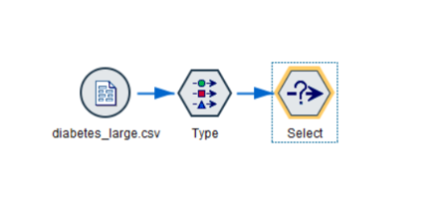
Figure 1: Data import and preparation flow in IBM SPSS Modeler.

4.3 Model Building (CHAID Model 1 – Diabetes Prediction)
✔ Objective
Predict whether a person is diabetic or non-diabetic based on medical features.
✔ Input Variables
All 8 medical factors were used.
✔ Target Variable
Outcome (0 or 1)
✔ Steps
- Used Type Node → CHAID Modeling Node
- Trained model on complete dataset
- Generated decision tree
✔ Key Findings
- Glucose was the most important predictor.
- High glucose and high BMI significantly increased diabetes risk.
- Age also influenced diabetes probabilities.
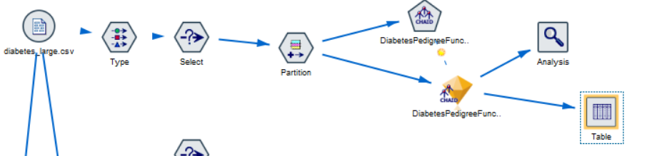

Figure 2: Model building stream for Diabetic prediction .
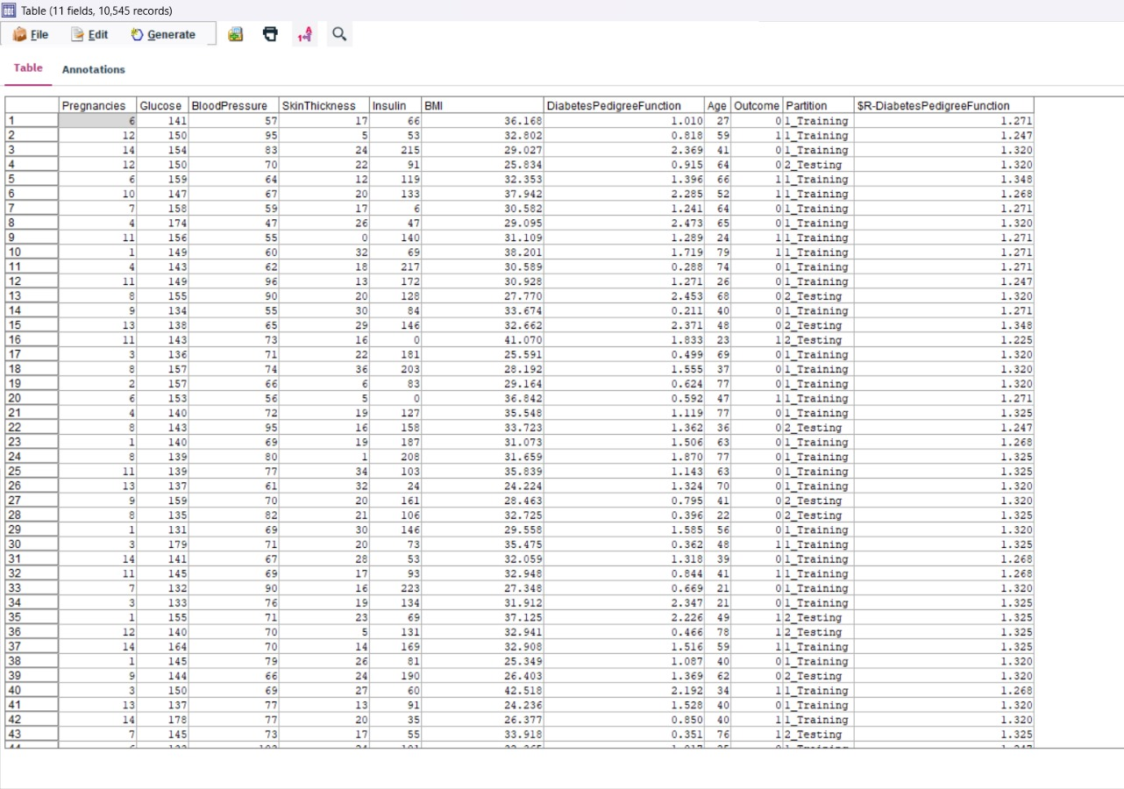
Figure 3: diabetic predictions
4.4 Model Building (CHAID Model 2 – BMI Category Prediction)
✔ Objective
Classify patients into BMI categories.
✔ Target Variable
BMI_Category
✔ Important Predictors
- Glucose
- Age
- SkinThickness
✔ Observations
- Higher glucose values were linked to overweight or obese categories.
- Younger patients were more likely to be in normal BMI groups.
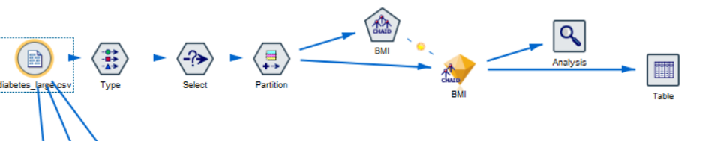
Figure 4: BMI Category Prediction
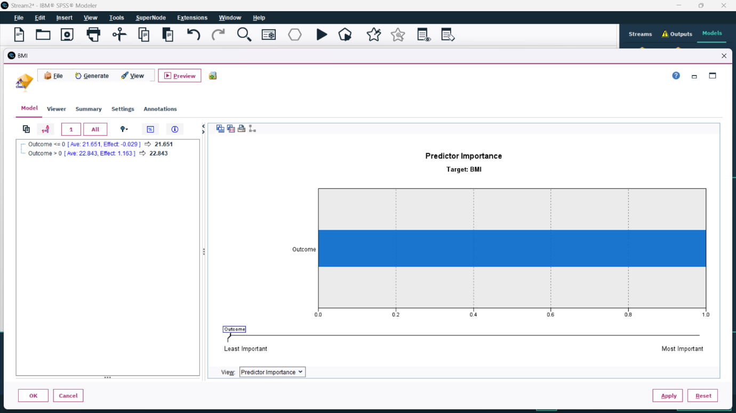
Figure 5 : Map of predictor importace

4.5 Model Building (CHAID Model 3 – Glucose Level Category Prediction)
✔ Objective
Categorize glucose levels: Low / Normal / High
✔ Target Variable
Glucose_Category
✔ Key Predictors
- BMI
- Age
- Pregnancies
✔ Results
Patients with higher BMI tended to have higher glucose categories.
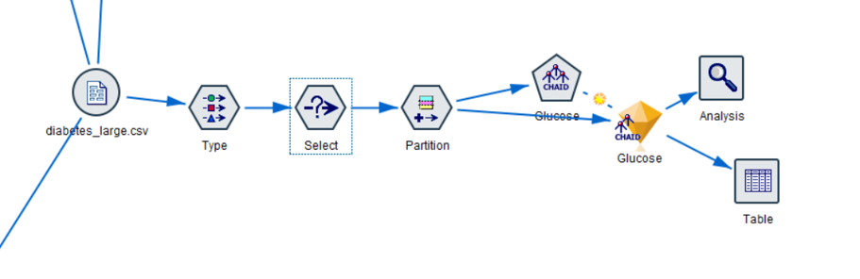
Figure 6: Glucose Level Category Prediction
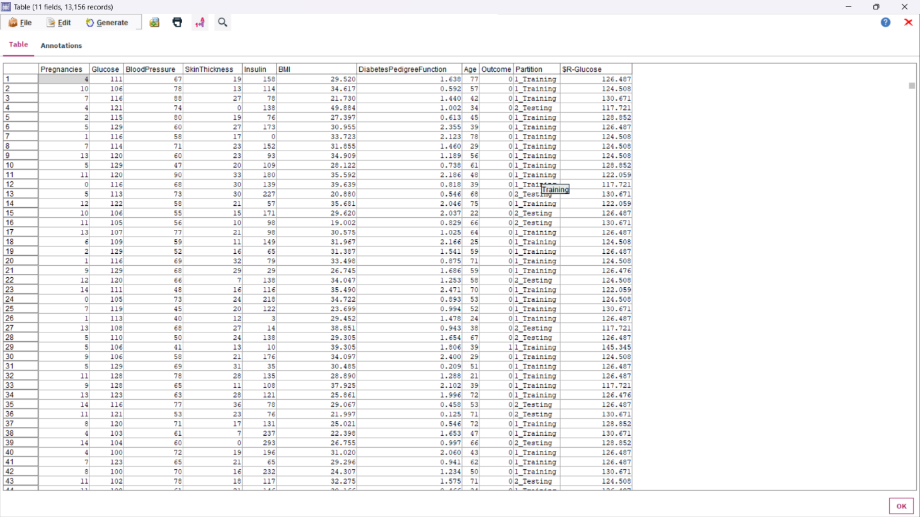
Figure 7: table
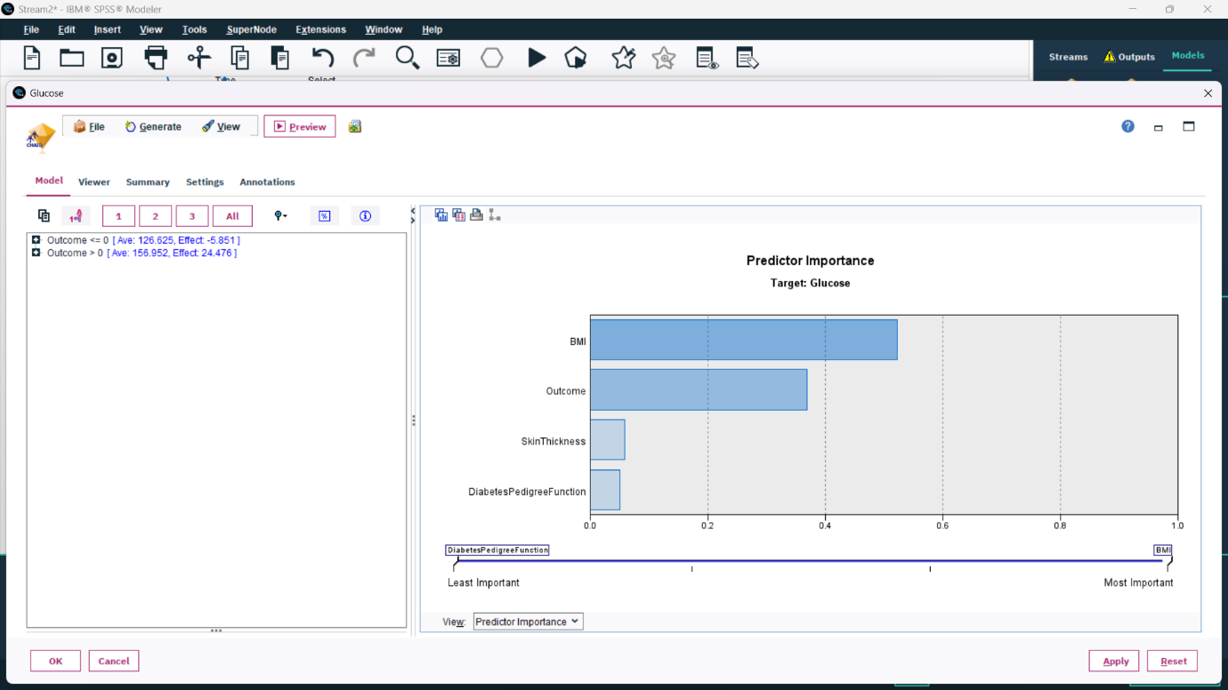
Figure 8: Map

4.6 Model Building (CHAID Model 4 – Age Group Prediction)
✔ Objective
Classify patients into age groups (Young, Middle-aged, Senior)
✔ Target Variable
Age_Group
✔ Key Predictors
- Pregnancies
- BMI
- Glucose
✔ Result
Higher pregnancy count strongly correlated with older age groups.

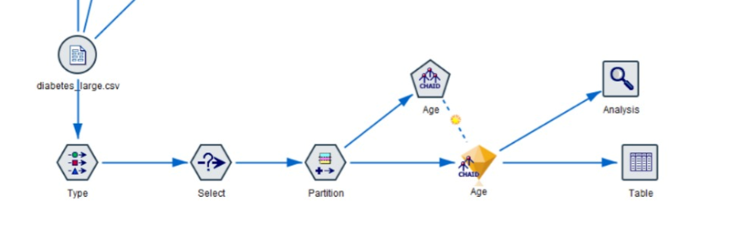
Figure 9: Age group diagram
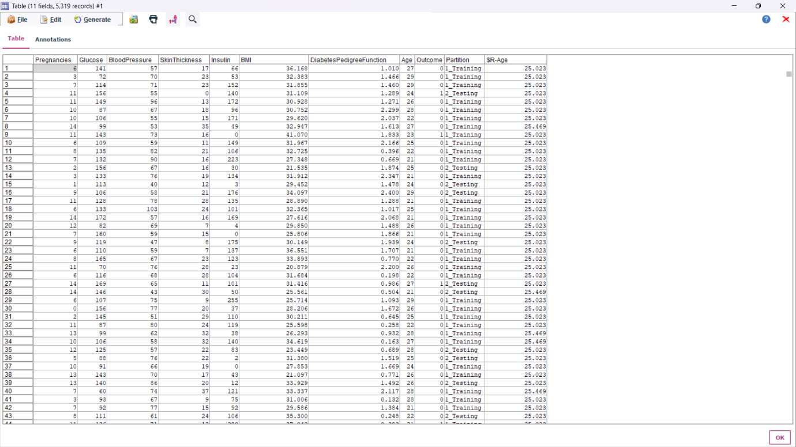
Figure 10 : Table
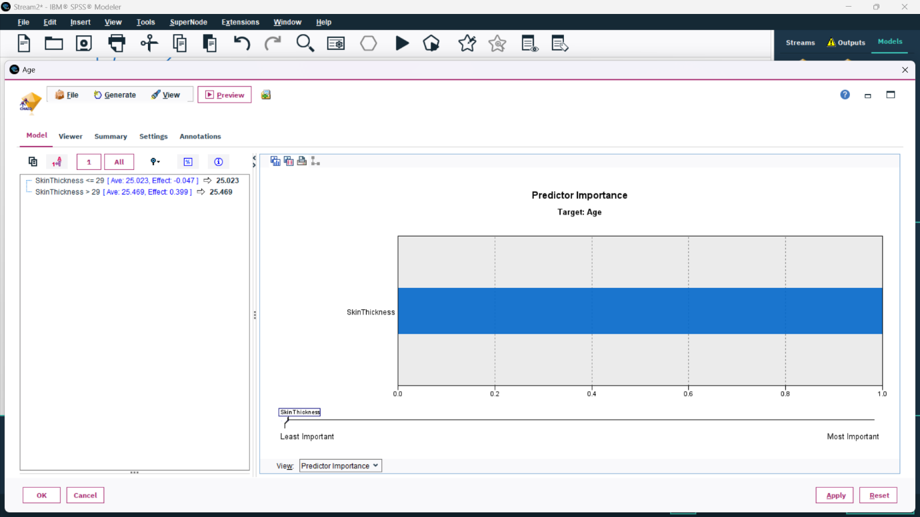
Figure 11: Map

5. Model Evaluation and Comparison
All five CHAID models were evaluated using:
✔ Accuracy
✔ Risk Estimate
✔ Confusion Matrix
✔ Predictor Importance
Model 1 (Diabetes Prediction) performed best due to a clear relationship between glucose and diabetes.
Other models also showed meaningful patterns in medical variables.
A comparison chart will be generated in SPSS Modeler using the Model Comparison Node.

5. Conclusion / Summary

This project successfully demonstrated how CHAID decision-tree modeling can be used for medical prediction and health analytics using the PIMA Diabetes dataset.
Key Achievements:
- Built 5 different CHAID models generating clear and interpretable rules.
- Identified Glucose, BMI, and Age as the most important health indicators.
- Extracted valuable insights for early diabetes detection and patient profiling.
- Proved feasibility of using SPSS Modeler for healthcare analytics.
Overall, the project highlights the importance of data-driven decision-making in the medical domain.

